Project Report Template

1. INTRODUCTION

1.1 Overview

Urban Aura Interiors is a design and interior decorating firm known for its expertise in creating stylish and functional interior spaces. They specialize in residential and commercial interior design, offering services such as space planning, furniture selection, color coordination, and decor arrangements. Urban Aura Interiors focuses on blending contemporary and traditional design elements to create unique and visually appealing environments. If you have specific questions or need more detailed information, please let me know.

1.2 Purpose

1. Capturing Urban Essence: The primary goal is to create interior spaces that encapsulate the unique atmosphere and character of urban environments, reflecting the energy, culture, and style of a particular city or neighborhood.

2. Functionality: Designing spaces that are highly functional and practical for urban living, considering the challenges and opportunities that come with limited space and urban lifestyles.

3. Client's Vision: Adhering to the client's vision and requirements, as every project may have specific objectives and themes based on the intended use of the space.

4. Innovation: Exploring innovative design concepts and solutions to make the most of urban spaces and to stand out in a competitive market.

5. Economic Viability: Depending on the project, ensuring that the interior design aligns with budget constraints and the economic realities of the urban market.

6. User Experience: Prioritizing the comfort and experience of the individuals who will live or work in these urban spaces, often involving elements such as ergonomics and usability.

2. PROBLEM DEFINITION & DESIGN THINKING

2.1 Empathy Map

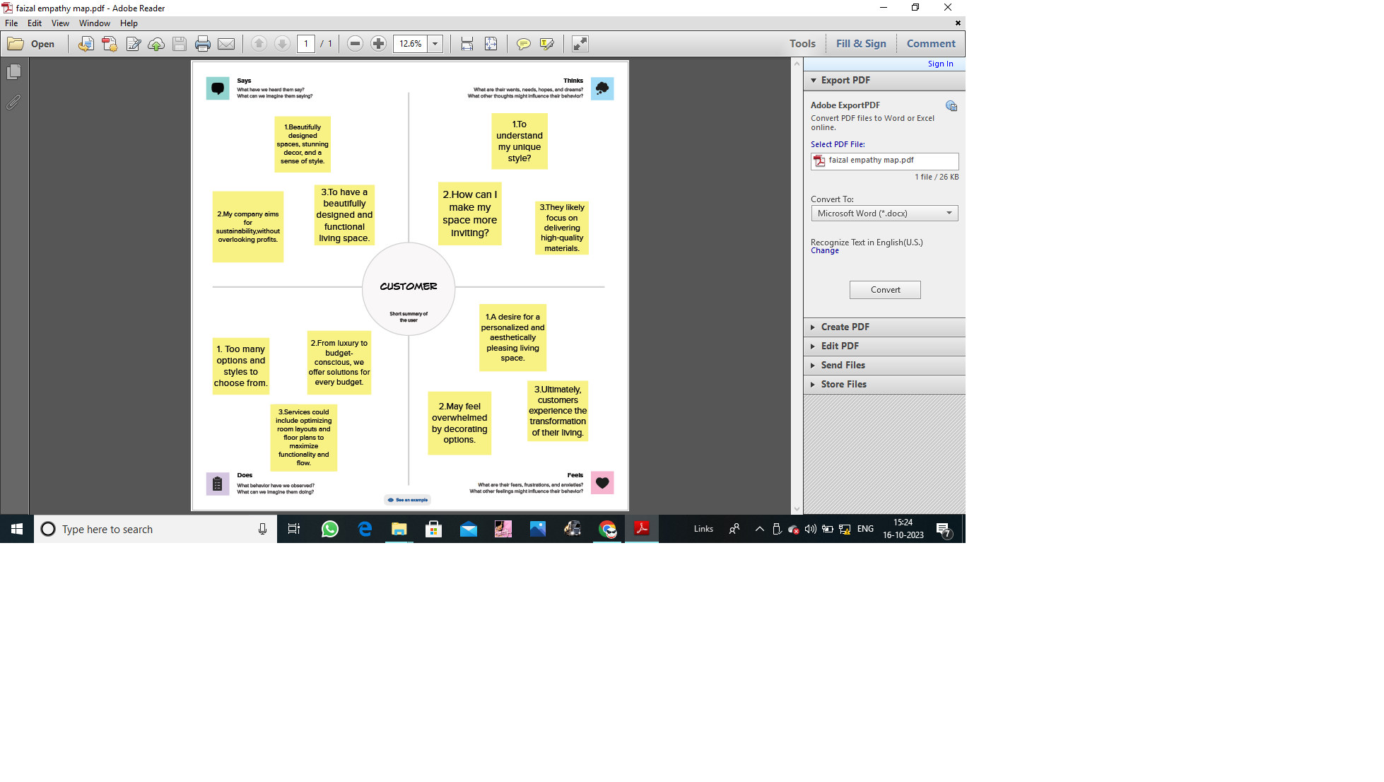

2.2 Ideation & Brainstroming Map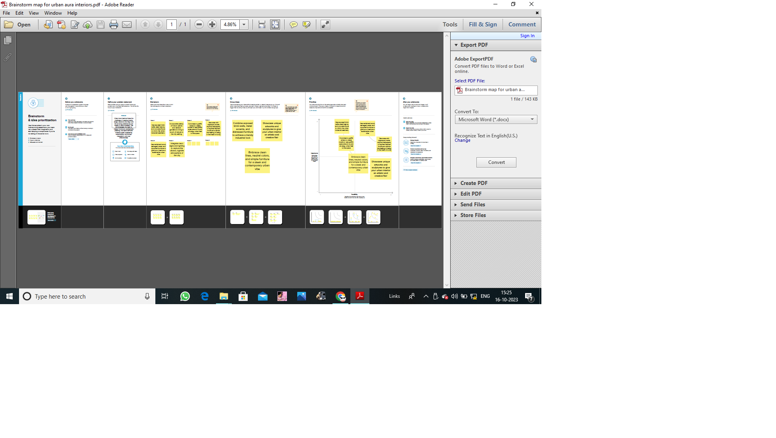

3. RESULT

As a large proportion of housing stock does not meet the current demands for energy and comfort (leading to high levels of obsolescence and vulnerability), the annual rate of energy upgrades for the existing stock must be increased.

Profit and loss account

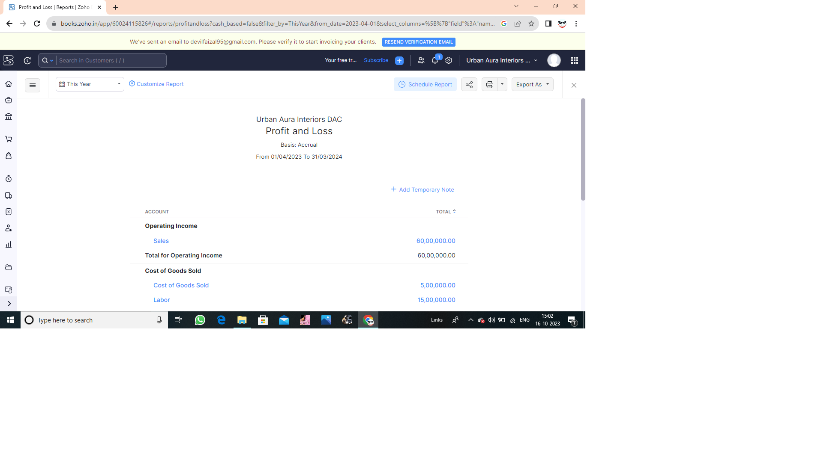

Balance sheet

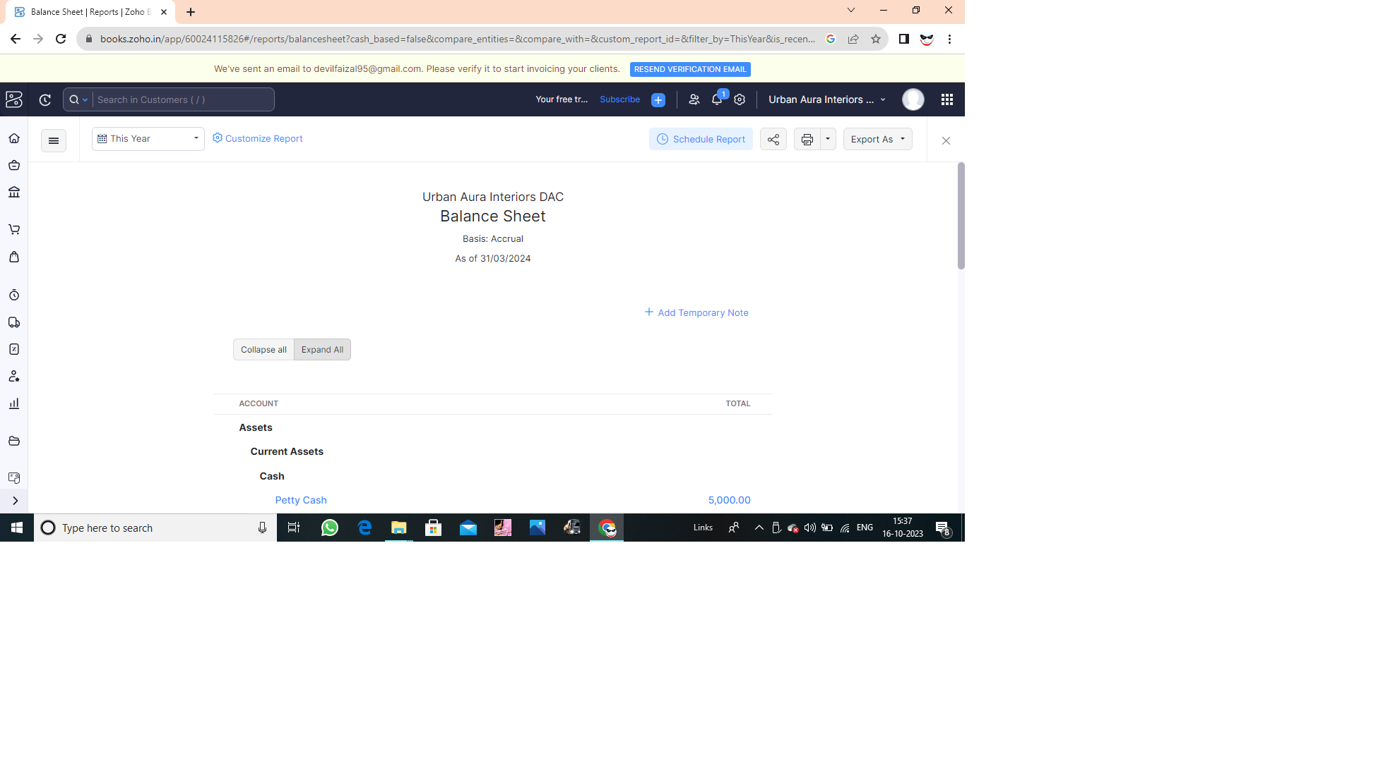

GST Reports

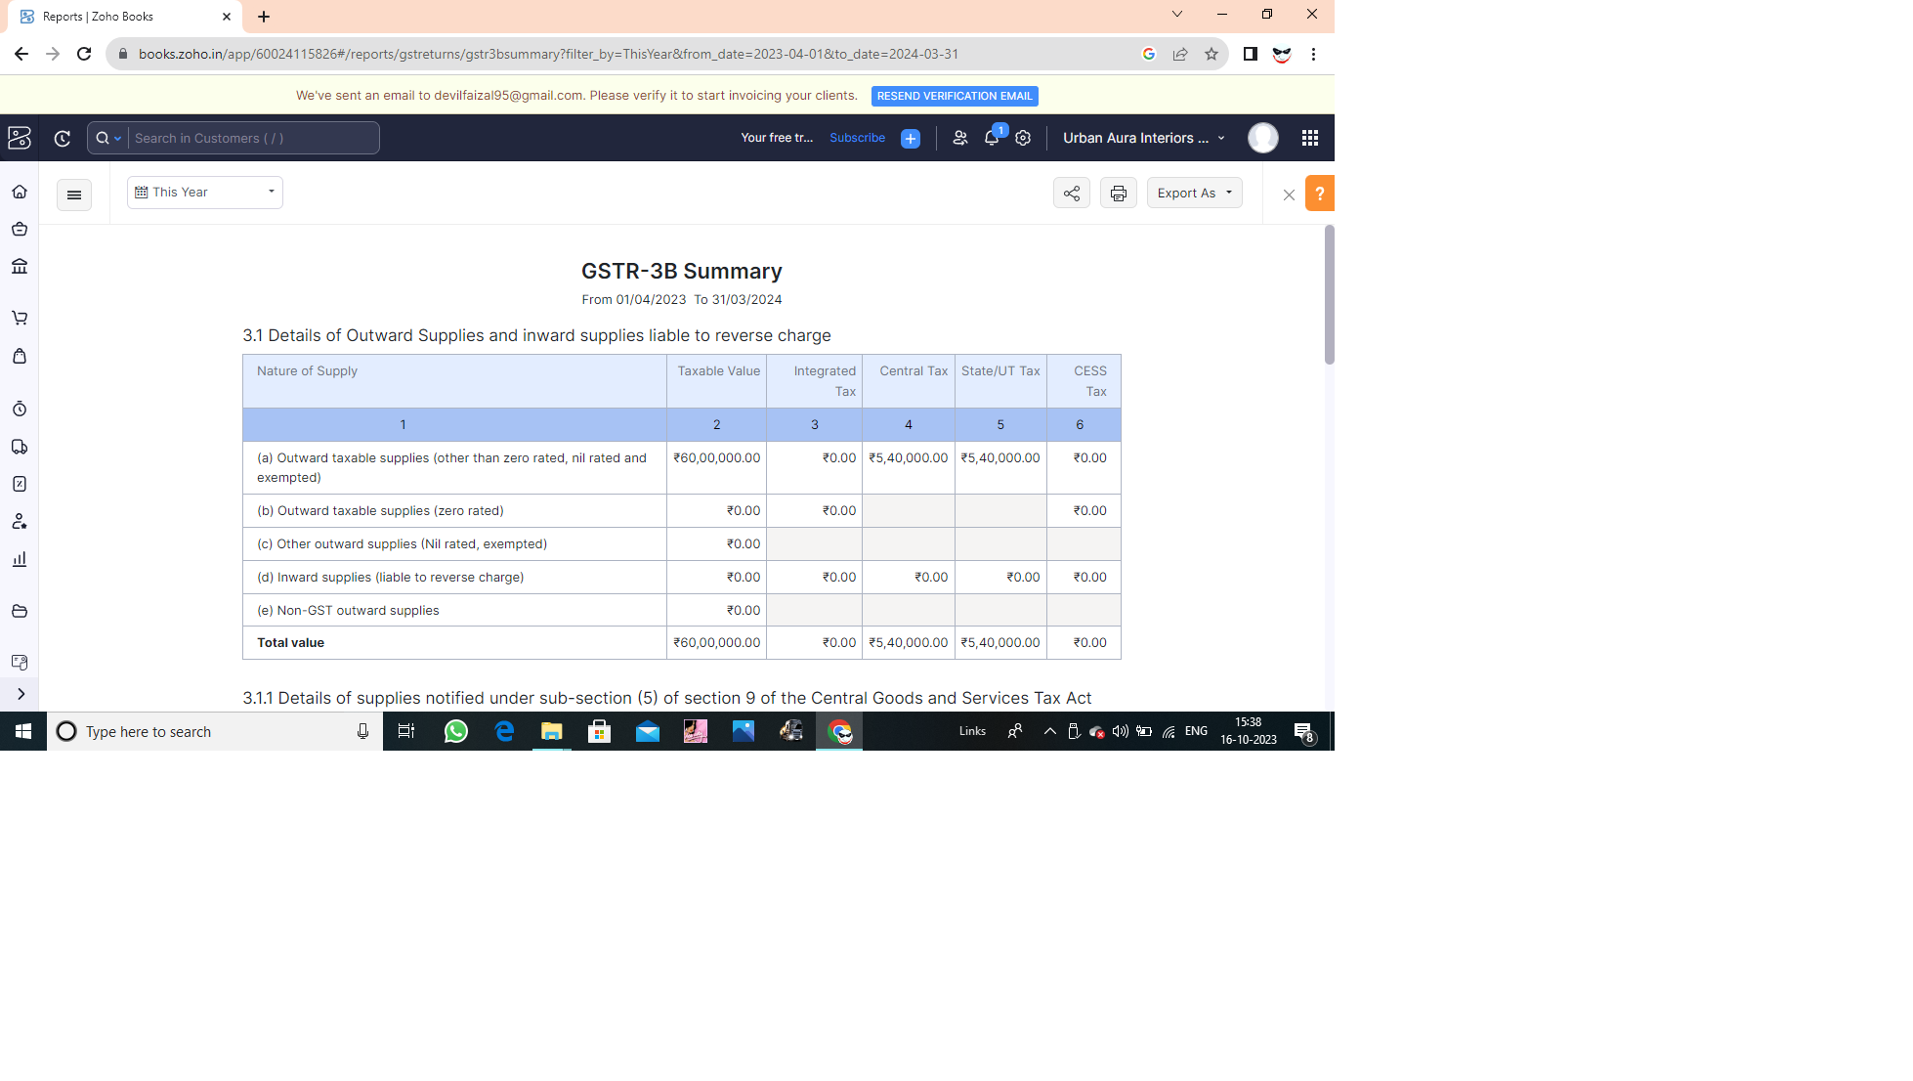

Tax Return

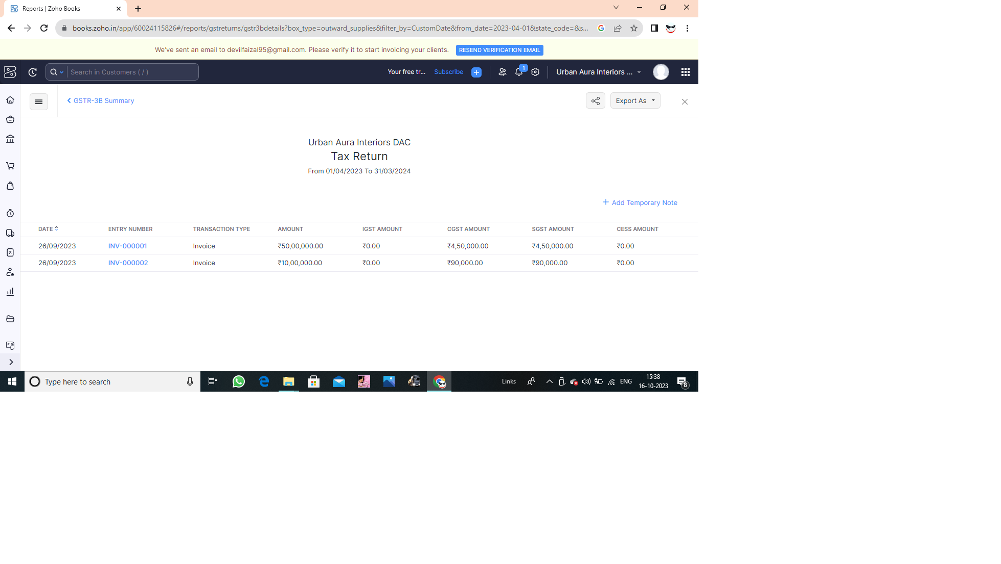Journal Report

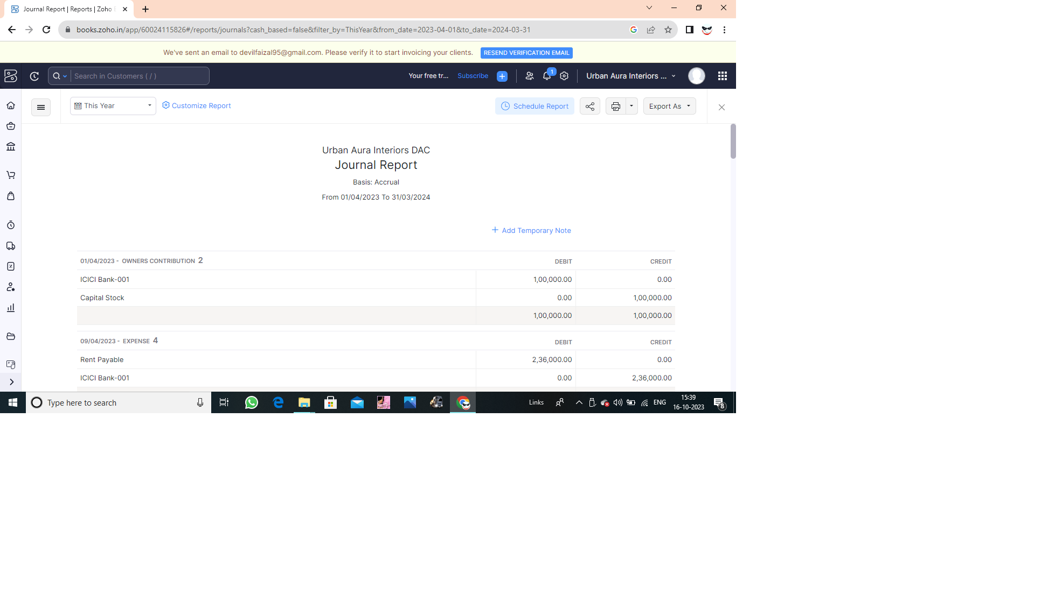

Accounts Receivable Aging Details

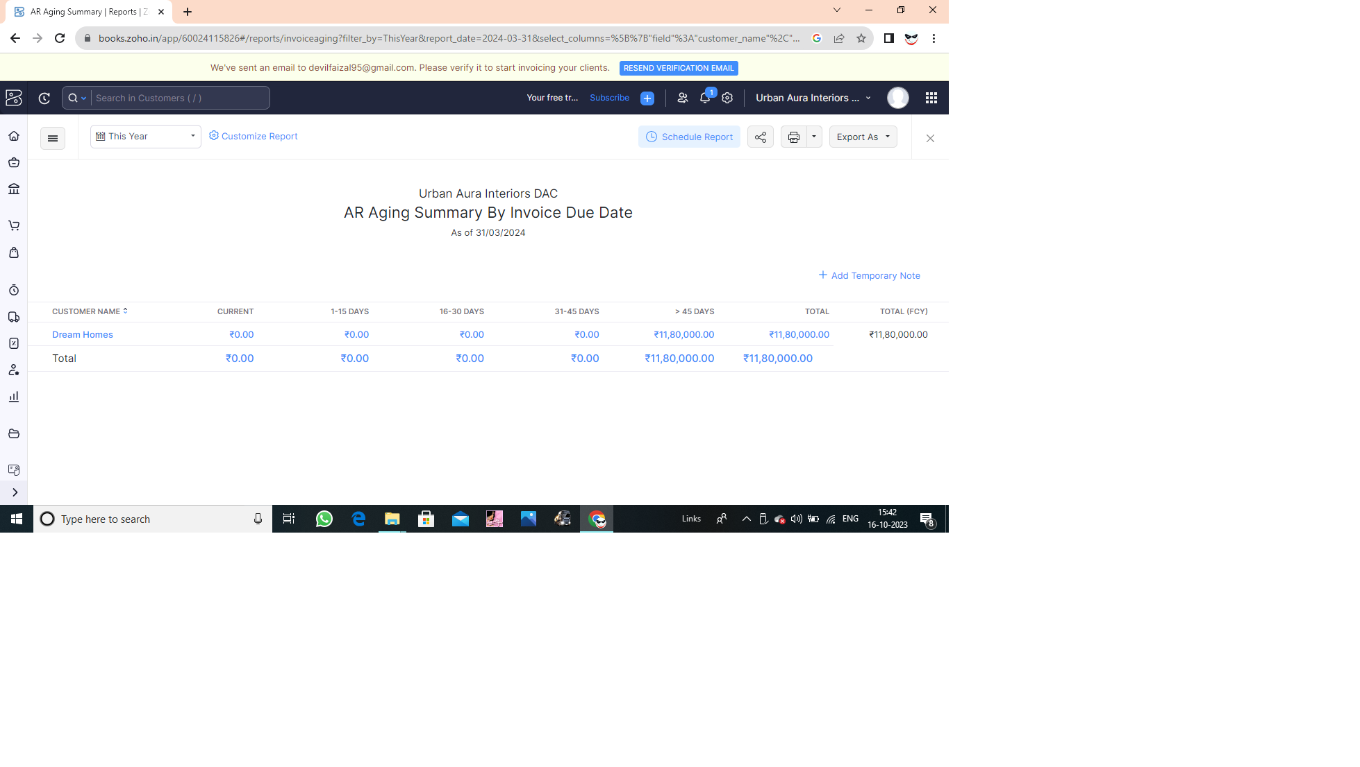

4. ADVANTAGES & DISASVANTAGES

The advantages typically outweigh the disadvantages when working with a reputable interior design firm like Urban Aura Interiors, but it's essential to consider your specific needs and budget.

Advantages

1. Professional Expertise: They offer professional design expertise to enhance your interior spaces.

2. Personalization: They tailor designs to your preferences, creating unique and customized environments.

3. Efficiency: Their experience can save time and money through informed design choices.

4. Access to Resources: They have access to a network of resources, from suppliers to contractors.

Disadvantages

1. Cost: Professional interior design services can be expensive, which might not fit all budgets.

2. Creative Differences: Your vision may not always align perfectly with the designer's, potentially leading to disagreements.

3. Time Commitment: Design projects can take time, and you'll need to coordinate with the designers.

4. Limited Control: You may have less control over design decisions if you rely heavily on the designer's expertise.

5. APPLICATIONS

Urban aura interiors refer to the design and decoration of interior spaces in urban settings. Here are some common applications and considerations for urban aura interiors:

1. Residential Spaces.

2. Commercial Spaces.

3. Restaurants and Cafes.

4. Hotels.

5. Public Spaces.

6. Mixed-Use Developments.

7. Adaptive Reuse Projects.

8. Sustainable Design.

9. Technology Integration.

10. Multi-Functional Furniture.

6. CONCLUSION

"In conclusion, the Urban Aura Interiors project successfully combined modern aesthetics with a touch of urban charm. The client expressed high satisfaction with the design, highlighting the integration of sustainable materials and the versatile use of space. Overcoming challenges related to limited space and budget constraints, the project stands as a testament to the team's creativity and adaptability in delivering a unique and appealing urban interior."

7. FUTURE SCOPE

The future scope of urban aura interiors is likely to be influenced by evolving design trends, sustainability, and technology.The integration of smart home technology into interior design, such as automated lighting, climate control, and security systems, will become more common.

8. APPENDIX

A.Source code